Over the last few weeks the software team has been hard at work producing a beautiful website (from scratch) to support our mission – which is now available on <http://teamcycl.one>, with code also available on GitHub, along with code which is being produced for the can, also including the libraries being produced for the sensor integration. Alongside a beautiful desktop interface, the website is responsive, adapting to mobile users allowing the website to more comfortably reach a greater range of people. Mobile applications have also been produced for Android and Windows Phone to allow the information to natively reach lots more people. Additionally, an iOS app is currently in Beta testing and we hope to release it soon to the App Store, where anyone can easily find out about our project.

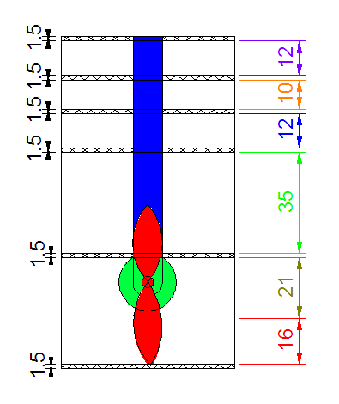

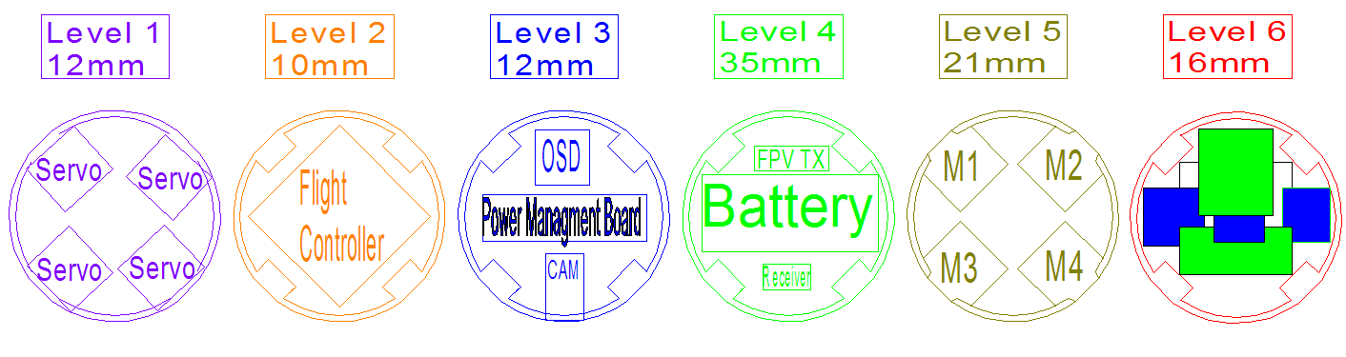Regarding the actual software and electronics of the can, much of the progress has been involved with confirming the choice of components that we wanted to use for the project. We have managed to gain a great sponsorship from Hobbyking, a wonderful supplier of all components for RC projects from whom the vast majority of our components will be sourced. The components from Hobbyking have been ordered and we are awaiting arrival. Additionally, we have worked with the structure team to model where the electronics will fit inside the can – producing a CAD design which the structure team I am sure will share here in due course when it has been completed. One major change has been moving away from the Intel Edison for the live streaming camera towards 5.8Ghz FPV camera system with an OSD if possible. The movement of the servos and motors will be controlled with a control board, while the sensors will be designed onboard a custom designed PCB. We have decided to use the excellent Bosch BME280 (with an option to change to the BME680) for pressure, temperature and humidity measurement, while a Sparkfun 6DOF breakout will be used for an IMU. The GPS system will use a GP2106 also making use of the Sparkfun GP2106 breakout board.

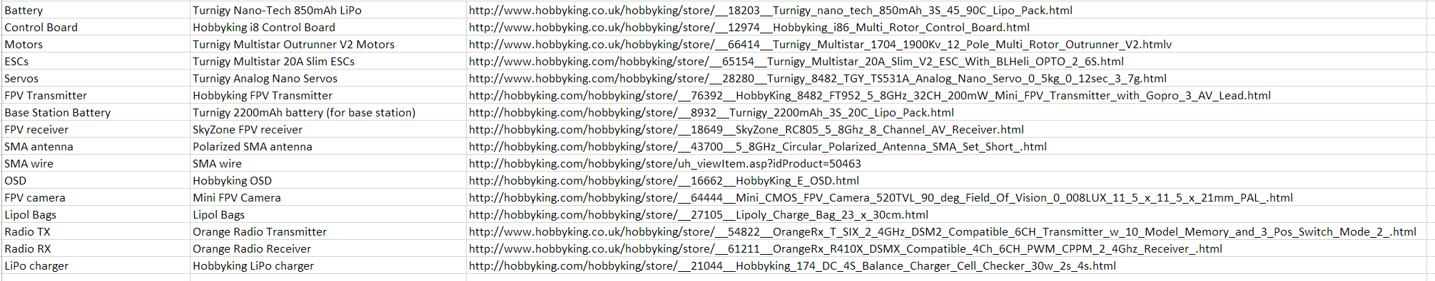

That’s all for now,

Ashwin,

Co-team leader

*LLAP*